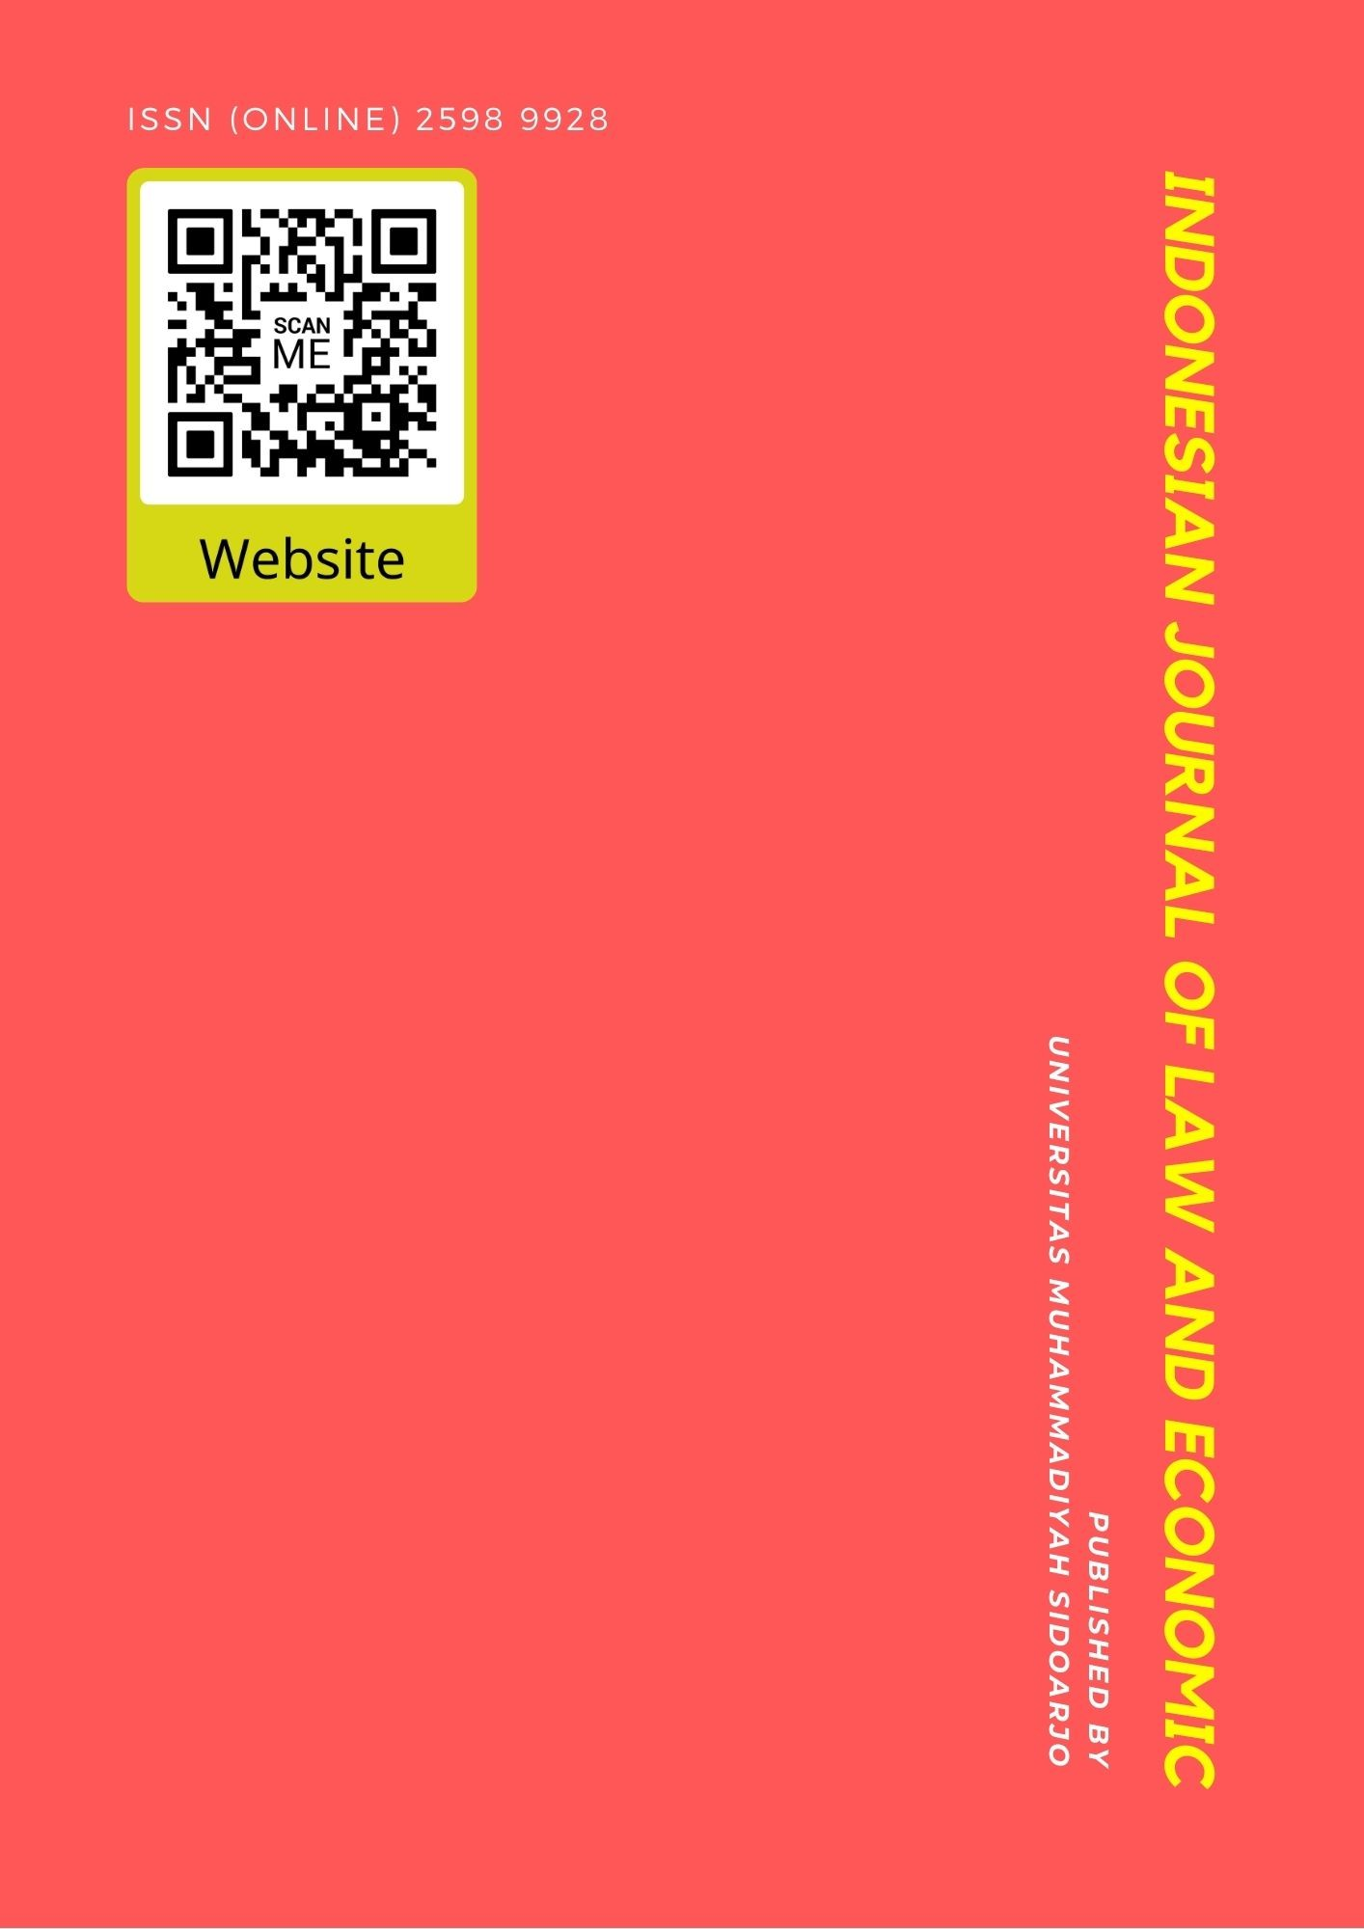

Table Of Contents
Journal Cover 1
Author[s] Statement 3
Editorial Team 4
Article information 5
Check this article update (crossmark) 5
Check this article impact 5
Cite this article 5
Title page 6
Article Title 6
Author information 6
Abstract 6
Article content 7

Originality Statement
The author[s] declare that this article is their own work and to the best of their knowledge it contains no materials previously published or written by another person, or substantial proportions of material which have been accepted for the published of any other published materials, except where due acknowledgement is made in the article. Any contribution made to the research by others, with whom author[s] have work, is explicitly acknowledged in the article.

Conflict of Interest Statement
The author[s] declare that this article was conducted in the absence of any commercial or financial relationships that could be construed as a potential conflict of interest.

Copyright Statement
Copyright © Author(s). This article is published under the Creative Commons Attribution (CC BY 4.0) licence. Anyone may reproduce, distribute, translate and create derivative works of this article (for both commercial and non-commercial purposes), subject to full attribution to the original publication and authors. The full terms of this licence may be seen at http://creativecommons.org/licences/by/4.0/legalcode

EDITORIAL TEAM

Editor in Chief

Dr. Wisnu Panggah Setiyono, Universitas Muhammadiyah Sidoarjo, Indonesia (Scopus) (Sinta)

Managing Editor
Rifqi Ridlo Phahlevy , Universitas Muhammadiyah Sidoarjo, Indonesia (Scopus) (ORCID)

Editors
Noor Fatimah Mediawati, Universitas Muhammadiyah Sidoarjo, Indonesia (Sinta

Faizal Kurniawan, Universitas Airlangga, Indonesia (Scopus)

M. Zulfa Aulia, Universitas Jambi, Indonesia (Sinta)

Sri Budi Purwaningsih, Universitas Muhammadiyah Sidoarjo, Indonesia (Sinta) Emy Rosnawati, Universitas Muhammadiyah Sidoarjo, Indonesia (Sinta)
Totok Wahyu Abadi, Universitas Muhammadiyah Sidoarjo, Indonesia (Scopus)

Complete list of editorial team (link)

Complete list of indexing services for this journal (link) How to submit to this journal (link)

Article information

Check this article update (crossmark)



Check this article impact ^{(*)}








Save this article to Mendeley



^{(*)} Time for indexing process is various, depends on indexing database platform

Brand Ambassador and Price Shape Consumer Purchasing Decisions

Habibil Muttaqien, mistihariasih@umsida.ac.id, , ()
Students of Management Study Program, University of Muhammadiyah Sidoarjo, Indonesia, Indonesia

Misti Hariasih, mistihariasih@umsida.ac.id, , ()
Lecturer of Management Study Program, University of Muhammadiyah Sidoarjo, Indonesia, Indonesia

⁽¹⁾ Corresponding author

Abstract

Background: The bottled drinking water (AMDK) industry in Indonesia continues to grow rapidly, supported by increased public awareness of clean and safe water consumption. Specific Background: Within this competitive market, Le Minerale strives to strengthen consumer purchase intentions through marketing variables such as brand ambassadors, product design, and price. Knowledge Gap: Previous studies have shown inconsistent results regarding the relationship between these variables and consumer purchasing decisions, necessitating further empirical validation. Aims: This study aims to analyze the roles of brand ambassadors, product design, and price in shaping consumer purchasing decisions for Le Minerale products in Sidoarjo. Results: Using a quantitative method with 100 respondents and multiple linear regression analysis, findings reveal that brand ambassadors and price significantly and positively affect purchasing decisions, while product design has no significant effect. Novelty: This study integrates consumer perception theory with marketing mix analysis in a specific local market, providing an updated empirical perspective. Implications: The results suggest that effective marketing strategies should prioritize credible brand ambassadors and affordable pricing to enhance purchase intentions in the bottled water industry.

Highlights:
- Brand ambassadors and price significantly influence purchasing decisions.
- Product design shows no significant relationship with consumer choice.
- Marketing strategy should focus on credibility and pricing competitiveness.

Keywords: Brand Ambassador, Product Design, Price, Purchasing Decision, Marketing Management

Published date: 2025-05-12

I. INTRODUCTION
Consumer News and Business Channel Indonesia in explaining that the AMDK or bottled drinking water industry is one of the fastest growing industries in Indonesia. The growing population of Indonesia makes the need for drinking water also higher considering that water is a primary human need. Based on statistical data as of June 2020, AMDK industry revenue grew by 40% in the last 5 years, namely from 2015-2019. Moreover, in the next 5 years, the AMDK industry is predicted to grow by an average of around 6.9% per year, so that the AMDK industry revenue in the next 5 years is predicted to reach $ 14.82 billion. This proves that the AMDK industry still has very bright prospects, so it is not surprising that many AMDK products are mushrooming in Indonesia. [1]
Sourced According to data from the Ministry of Industry, the Association of Bottled Water Companies (Aspadin) summarizes that there are approximately 700 AMDK business actors, of which 90% are small and medium segment businesses.2 This has resulted in intense competition between AMDK companies to attract consumer attention. The presence of various AMDK business companies makes people more critical and selective in choosing bottled water products that are clean and safe for the human body. [2]One of the AMDK products in Indonesia is Le Minerale. Le Minerale is a product made by a subsidiary of PT Mayora Indah named PT Tirta Fresindo Jaya which is engaged in beverages.3Le Minerale products began to be introduced to Indonesian consumers in 2015. Le Minerale's unique tag line, "Kayak Ada Manis manisnya" makes it easy for Indonesian consumers to remember. So that it succeeded in juxtaposing Le Minerale into one of the mineral water brands in Indonesia.
Le Minerale is still very young compared to its competitors in the AMDK industry. Therefore, it takes extra hard effort to be able to compete with brands that have first accompanied Indonesian consumers. Le Minerale must be able to prove that this product can survive and develop in Indonesia by continuing to improve product quality so that it can still be the choice of Indonesian consumers from various circles and can still prove its existence among the many onslaughts of senior competitors.[2]
One of le minerale's efforts to become a market leader in this industry is the use of marketing strategies that are quite effective to encourage consumers to switch from buying competitive products to Le Minerale products. Kotler stated in general [2] that marketing is a function in the organization as well as a set of processes by realizing, communicating and delivering value to consumers so as to form a mutually beneficial relationship between consumers and organizations. Kotler and Armstrong in Simamoramen define marketing management as an analysis of a planning, implementing, and managing programs that have been designed in order to realize, build and maintain a sense of mutual benefit with consumers in order to achieve company targets and goals.

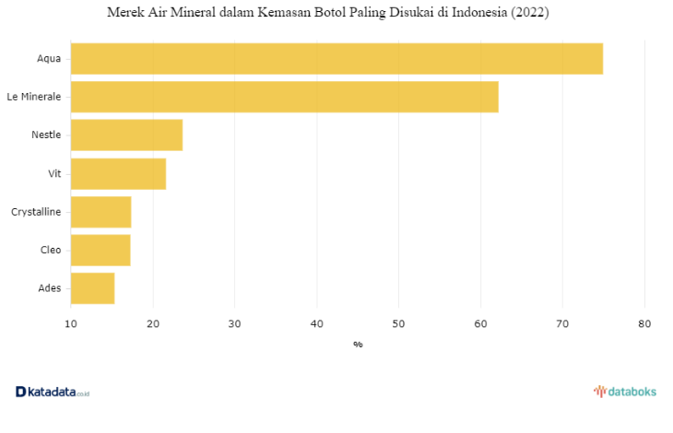

Figure 1. The Most Preferred Bottled Mineral Water Brand in Indonesia (2022)
(Source: https://databoks.katadata.co.id)

According to Kotler and Armstrong, purchasing [3] decisions are the buying behavior of end consumers in which they buy goods or services to consume. Kotler and Ketler [3] in stating: "consumer behavior is the study of how individuals, groups, and organization select, buy, use and dispose of goods, service, ideas, or experiences to satisfy their needs and wants." According to Sitompul in [9] purchasing decision indicators, namely:[4]
1. Needs identification: The process of identifying consumers against the needs they need.
2. Digging for product information : Looking for information on a product or brand to convince yourself before buying a product
3. Making a product purchase: The process of exchanging goods by the seller for money by the buyer
4. Post-purchase behavior: A series of actions performed by the buyer after consuming or using a product that has been purchased.
There is a strategy aimed at attracting consumer buying interest in e-commerce products, brand ambassadors are needed so that the product can be sold so that it can increase a value in the product. As explained that brand ambassadors as a tool or promotional media to offer a product and as a means of increasing sales. This relates greatly to LeaGreenwood in [5] saying brand ambassadors are a tool used by companies to communicate and connect with the public on how they actually increase sales. According to Kertamukti, in [6] stating that marketing activities against the use of celebrities are evaluated using the VisCAP method. This method can be used as a characteristic of brand ambassadors with objective communication. The model is used to evaluate potential brand ambassadors for consumer perceptions. According to Kertamukti, the VisCAP method from John R. Rossiter consists of four indicators, including the following:
1. Visibility : Something or somethingthat is famous and known by many people
2. Credibility: Have the ability or skill in their fieldto be trusted
3. Attraction : Anindividual's ability to attract the attention of the general public
4. Power : The power of individuals to influence potential buyers
According to Darman and Susetyowati , product [7] design is the totality of features that affect the appearance, taste, and function of the product based on customer needs. According to Handayani, Derriawan and Tyahya in [7]. Product design is a value contained in the product in the form of a distinctive and attractive product appearance and can be a differentiator from competing products Product Product design is the totality of features that affect the appearance, taste, and function of the product based on customer needs. Achidah, Warso and Hasiholan in [8] showing product design indicators, namely:
1. Latest model : the brand has a design that consumers like because it is new
2. Design variations: brands have various types ofdesigns
3. Trend-following design: product design thatis not considered old-fashioned by buyers
4. Design appeal : consumers like to have an interest in the design form of the brand
According to Kotler and Armstrong, price is the amount of [9] money charged for a good or service or the amount of money that consumers exchange for the benefits of owning or using the product or service. According to Philip Kotler in [9] price is the amount of money that the customer has to pay for that product. Tjiptono [9] defines price as one element of the marketing mix that generates revenue; the other element generates costs for the company. Perhaps price is the easiest element in a marketing program to customize; Product features, channels, even communication takes more time. Price also communicates the positioning of the intended value of a company's product or brand to the market. Well-designed and marketed products can be sold at high prices and make huge profits Products with poor quality, expensive prices, slow products can make customers dissatisfied. In [10] Kotler and Armstrong stated the price indicator is :
1. Affordability: the price offered by the seller to the buyer is in accordance with the consumer's ability to buy
2. Discount: price reduction by the seller to the buyer in the hope of attracting buying interest
3. Price competitiveness: products from a brand are able to compete on price with other brands in the same industry
4. Suitability of price with benefits: the price offered by the seller to the buyer has a value according to what the buyer expects to get benefits
Buildinga brand is not easy, it takes time, repeated improvements and research to find out how to increase sales. In research conducted by Elvina & Nugroho in [11] Brand Ambassadors has a positive and significant influence on purchasing decisions on Tokopedia and Shoope. Theresults of research conducted by Agnes & Ahmad in Brand Ambassadors[12] did not affect the decision to purchase the Sulthanah Hijab in Tegal City.
Nur'aeni & Supartono in conducting research on the Influence of Honda Beat motorcycle design at Universitas Pelita Bangsa, found that product design has a positive [7]and significant impact on purchasing decisions. however, from the results of Fauzy & Rafikasari's research in AMDK brand Le Minerale did not [2]affect the purchase decision of FEBI IAIN Tulungagung.
The results of research conducted by Noviyanti, Sunarsi & Suyono [13] show that harga has a significant positive influence on purchasing decisions at Alfamart Cistupid branch. Meanwhile, a study conducted by Destarini & Prambudi in, price [14]b has a negative and insignificant influence on purchasing decisions on consumers of 212 Mart Condet Batu Ampar.
Based on previous research, there are inconsistencies in the results of previous research on Brand Ambassador, Product Design and Price variables on Purchasing Decisions so that re-research or re-verification is needed to identify the variables to be studied whether they are influential or not. This kind of research is needed so that it can be used as a research development with marketing topics. The results obtained can help marketers in increasing their business. Based on the explanation above, researchers have a purpose that aims to recognize the influence of Brand Ambassadors, Product Design, and Price on purchasing decisions. This research will be carried out on Le Minerale consumers, in connection with which this research carries the title "Brand Ambassador, Product Design and Price to Purchasing Decisions".
II. METHODOLOGY
In this study using a quantitative approach with survey methods. Information from consumers who purchased Le Minerale. The population of this study is an unknown number of Le Minerale consumers in Sidoarjo, East Java. [9] This research data collection method uses non-probability sampling procedures by using purposive sampling or data collection sourced from parameters that have been determined with the following criteria: 1) buying Le Minerale products and 2) having social media.

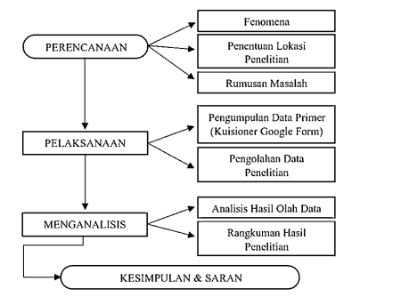

Figure 2. Stages of research

There is no data stating the exact population size, so the sample is determined based on Ghozali's opinion in:[15] which states that the minimum number of samples ranges from 100-200 samples. The source of information was processed with a questionnaire measured by the Likert scale, with each variable having 4 [16]statements then analyzed with SPSS 25 using the analysis method of validity test, reliability test, classical hypothesis test, multiple linear regression analysis and hypothesis test. The purpose of this study was to examine the relationship between brand ambassadors, product design and price to purchasing decisions.

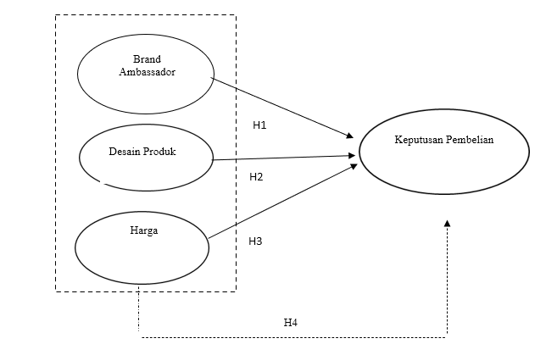
Figure 3. Conceptual Framework

From the conceptual framework above, the research hypothesis can be obtained. The research hypothesis is interpreted as a conjecture or temporary statements about the relationship between variables that are logical 40. Hypothesis on this research as follows:
H1: Brand Ambassadors influence purchasing decisions
H2: Product Design influences purchasing decisions
H3: Price influences purchasing decisions
H4: Brand ambassadors, product design, and price influence purchasing decisions

III. RESULTS AND DISCUSSION

A. Characteristics of Respondents
The characteristics of respondents in this study researchers divided into four characters, namely: gender, age, occupation and monthly income. Description of the characteristics of the researcher's research respondents is described in the subchapter below:

    - Characteristics of respondents by gender

Gender | Frequency | Percentage
Male | 61 | 61%
Woman | 39 | 39%
Total | 100 | 100%
Table 1. Characteristics of respondents by gender

Based on the table above, it is known that the respondents are male, with a percentage of 61% and the a side is a womanwith a percentage of 39%, this shows that men are the respondents with the largest number in this study.

    - Characteristics of respondents by age
Age | Frequency | Percentage
< 20 Years | 10 | 10%
21 - 30 Years | 81 | 81%
31 - 40 Years | 5 | 5%
41 - 50 Years | 1 | 1%
> 51 Years | 3 | 3%
Total | 100 | 100%
Table 2. Characteristics of respondents by age

Based on the table above, it is known that respondents are 21 – 30 years old, with a percentage of 8.1%, their sis a < 20 years, 31 – 40 years , 41 – 50 years old and > 51 years old with a total percentage of 19%, this shows that um your 21 – 30 years is the respondent with the highest number in this study.
    - Characteristics of respondents by occupation
Work | Frequency | Percentage
Student | 71 | 71%
Teacher/Lecturer | 11 | 11%
Self employed | 8 | 8%
Entrepreneurial | 7 | 7%
Other | 3 | 3%
Total | 100 | 100%
Table 3. Characteristicsof Respondents By Occupation

Based on the table above, it is known that respondents who have the status of students and students a, with a percentage of 7.1% on the side are teachers / dosen, entrepreneurs, entrepreneurs and others of 2.9%, this shows that students and studentsa are the respondents with the highest number in this study.

    - Characteristics of respondents based on income per month
Revenue Per Month | Frequency | Percentage
< IDR 2,000,000 | 72 | 72%
IDR 2,000,001 - IDR 5,000,000 | 22 | 22%
IDR 5,000,001- IDR 10,000,000 | 4 | 4%
>IDR 10,000.001 | 2 | 2%
Total | 100 | 100%
Table 4. Characteristics of respondents based on income per month
Based on the table above, it is known that respondents have an income of < IDR 2,000,000, with a percentage of 72% and the side is IDR 2,000,001 - IDR 5,000,000, IDR 5,000,001 - IDR 10,000,000 and > IDR 10,000,001 with a percentage of 2.8%, this shows that the income < IDR 2,000,000 is the respondent with the highest number in this study.

B. Validity Test

Variable | Indicators | r _{calculate} | Construct | Information
Brand Ambassador (X1) | X _{1.1} | 0,878 | 0,3 | Valid
Brand Ambassador (X1) | X _{1.2} | 0,839 | 0,3 | Valid
Brand Ambassador (X1) | X _{1.3} | 0,888 | 0,3 | Valid
Brand Ambassador (X1) | X _{1.4} | 0,859 | 0,3 | Valid
Product Design (X2) | X _{2.1} | 0,835 | 0,3 | Valid
Product Design (X2) | X _{2.2} | 0,836 | 0,3 | Valid
Product Design (X2) | X _{2.3} | 0,831 | 0,3 | Valid
Product Design (X2) | X _{2.4} | 0,848 | 0,3 | Valid
Price (X3) | X _{3.1} | 0,828 | 0,3 | Valid
Price (X3) | X _{3.2} | 0,763 | 0,3 | Valid
Price (X3) | X _{3.3} | 0,806 | 0,3 | Valid
Price (X3) | X _{3.4} | 0,747 | 0,3 | Valid
Purchase Decision (Y) | Y _{1.1} | 0,845 | 0,3 | Valid
Purchase Decision (Y) | Y _{1.2} | 0,843 | 0,3 | Valid
Purchase Decision (Y) | Y _{1.3} | 0,804 | 0,3 | Valid
Purchase Decision (Y) | Y _{1.4} | 0,777 | 0,3 | Valid
Table 5. Validity Test

According to Sugiyono dalam[17], if the correlation between the score of the question item and the total variable score is equal to 0.3 or more (at least 0.3), then the instrument item is declared valid. From the results of the validity test calculation, it is determined that the value of all provisions of each variable is r calculation > construction, allowing this research to be validated and used to measure the variables studied.

C. Reliability Test

Variable | Cronbach's Alpha | r _{critical} | Information
Brand Ambassador (X1) | 0,888 | 0,6 | Reliable
Product Design (X2) | 0,853 | 0,6 | Reliable
Price (X3) | 0,777 | 0,6 | Reliable
Purchase Decision (Y) | 0,828 | 0,6 | Reliable
Table 6. Reliability Test

Based on the table above, it is known that the reliability test value in this research is declared reliable with Cronbach's alpha results above 0.60 (>0.60) [18]. For Brand ambassador variables with a value of 0.888, Product design 0.853, Price 0.777 and purchase decision 0.828, all variables can be said to be reliable.[17]

D. Classical Assumption Test
1. Normality Test
One-Sample Kolmogorov-Smirnov Test
 |  |  | Unstandardized Residual
N |  |  | 100
Normal Parameters^{a,b} | Mean |  | 0
Normal Parameters^{a,b} | Std. Deviation |  | 2,1420541
Most Extreme Differences | Absolute |  | 0,101
Most Extreme Differences | Positive |  | 0,085
Most Extreme Differences | Negative |  | -0,101
Test Statistics |  |  | 0,101
Asymp. Sig. (2-tailed) |  |  | .014^{C}
Monte Carlo Sig. (2-tailed) | Sig. |  | .252^{s}
Monte Carlo Sig. (2-tailed) | 99% Confidence Interval | Lower Bound | 0,24
Monte Carlo Sig. (2-tailed) | 99% Confidence Interval | Upper Bound | 0,263
a. Test distribution is Normal.
b. Calculated from data.
c. Lilliefors Significance Correction.
d. Based on 10000 sampled tables with starting seed 2000000.
Table 7. Normality Test
The normality test results above display a Kolmogorov-Smirnov test value of 0.252 which is above the test requirement of 0.05. From the results of the study, it can be concluded if the information is distributed normal [18]

2. Autocorrelation Test
Model Summary^{b}
Type | R | R Square | Adjusted R Square | Durbin-Watson
1 | .763ª | 0,582 | 0,569 | 2,047
a. Predictors: (Constant), Price (X3), Product Design (X2), Brand Ambassador (X1)
b. Dependent Variable: Purchase Decision (Y)
Table 8. Autocorrelation Test
From the results above,it is known that the Durbin-Watson value is 2.047 which is still below the autocorrelation standard of 5.[ 20] In other words, the multiple regression used in this study has no autocorrelation.
3. Heteroscedasticity Test
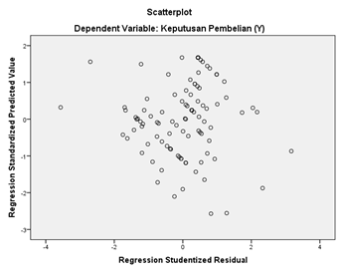
Figure 4. Heteroscedasticity Test
From the photo above, it appears that there is no pattern created and the dots are scattered randomly either above the number 0 or below the number 0 on the vertical axis or the Y axis. From this it can be concluded that heteroscedasticity is not established here.[18]

4. Multicolonicity Test

Type |  | Unstandardized Coefficients |  | Standardized Coefficients | t | Sig. | Collinearity Statistics
 |  | B | Std. Error | Beta | t | Sig. | Tolerance | VIF
1 | (Constant) | 0,956 | 1,326 |  | 0,721 | 0,473
1 | Brand Ambassador (X1) | 0,289 | 0,076 | 0,322 | 3,813 | 0 | 0,61 | 1,639
1 | Product Design (X2) | 0,162 | 0,093 | 0,145 | 1,75 | 0,083 | 0,634 | 1,577
1 | Price (X3) | 0,453 | 0,097 | 0,422 | 4,683 | 0 | 0,536 | 1,865
a. Dependent Variable: Purchase Decision (Y)
Table 9. Multicolonicity Test

Based on the results above, weknow the variance inflation factor (VIF) value of the brand ambassador variable of 1.639 (0.1), the value of the product design variable of 1.577 (0.1 ), and the value of the price variable of 1.577 (0.1). 1.865 (0.1) until it can be concluded that the multiple linearity regression used in this study is free from multicollinearity which means that multicollinearity between variables is not intertwined.[18]

E. Multiple Linear Regression Analysis
Type |  | Unstandardized Coefficients |  | Standardized Coefficients | t | Sig.
 |  | B | Std. Error | Beta | t | Sig.
1 | (Constant) | 0,956 | 1,326 |  | 0,721 | 0,473
1 | Brand Ambassador (X1) | 0,289 | 0,076 | 0,322 | 3,813 | 0
1 | Product Design (X2) | 0,162 | 0,093 | 0,145 | 1,75 | 0,083
1 | Price (X3) | 0,453 | 0,097 | 0,422 | 4,683 | 0

Table 10. Multiple Linear Regression Analysis

Based on the results in the table above, it can be seen that the four-variable regression model looks like this:
Y=a + b 1 X 1 + b 2 X ₂ ₊ b 3 X₃e ₁
Y=0.956+ 0.289 X1 + 0.162 X2+0.453 X3 + e 1 [18]
Based on the results of the capture equation, the meaning and significance of the regression coefficient can be explained as follows:

- Constant (a)
The value of the coefficient is positive 0.956. This shows that without the influence of the variables free Brand Ambassador, Product Design and Price, the value of the purchase decision of the dependent variable is always constant at 0.956.

- Brand Ambassador
The value of the positive coefficient between the variable brand ambassador and the purchase decision is 0.289. Thisshows that the two variables are positively related. From this it can be concluded that the purchase decision variable increased by 0.289 when the variable "Brand Ambassador" increased by one unit.

- Product Design
The value of the positive coefficient between product design variables and purchasing decisions is 0.162. This showsthat both variables are positively related. For every increase in one unit of product design variable, the purchase decision variable increased by 0.162.

- Price
The value of a positive coefficient of 0.453 between the variable harga and the purchase decision. Thisillustrates that the two variables are positively related, so it can be concluded that if the variable increases by one unit, the purchase decision variable increases by 0.453.

F. Test the hypothesis
    - Partial Test (Test t)
Type |  | Unstandardized Coefficients |  | Standardized Coefficients | t | Sig.
 |  | B | Std. Error | Beta | t | Sig.
1 | (Constant) | 0,956 | 1,326 |  | 0,721 | 0,473
1 | Brand Ambassador (X1) | 0,289 | 0,076 | 0,322 | 3,813 | 0
1 | Product Design (X2) | 0,162 | 0,093 | 0,145 | 1,75 | 0,083
1 | Price (X3) | 0,453 | 0,097 | 0,422 | 4,683 | 0
Table 11. Partial Test (Test t)
This test plays a role in recognizing Brand Ambassador, Product Design and Price variables Influential significantly or not to the Purchase Decision variable. If the t-test results create a significance smaller than 0.05 (sig &lt; 0.05) until the research hypothesis is accepted.[19]

In the partial test results (T) on the influence of each variable X on the Purchase Decision variable (Y), it can be described as follows:

- Brand Ambassador for Purchasing Decisions
The significance value of the variable (X1) against the variable (Y) is obtained at 0.0 where the value matches the test conditions is (sig<0.05). And with an influence of 0.289, it means that partially the Brand Ambassador variable (X1) has a positive and significant effect on the consumer Purchase Decision variable on Le Minerale products in Sidoarjo City.

- Product Design to Purchasing Decisions
The significance value of the variable (X2) against the variable (Y) is obtained at 0.083 where the value does not match the test conditions is (sig<0.05). And with an influence of 0.162, it means that partially the Product Design variable (X2) has an effect and is not significant on the consumer Purchase Decision variable on Le Minerale products in Sidoarjo City.
- Price to Purchase Decision
The significance value of the variable (X3) against the variable (Y) is obtained at 0.000 where the value matches the test conditions is (sig<0.05). And with an influence of 0.453, it means that partially the Price variable (X3) has a positive and significant effect on the consumer Purchase Decision variable on Le Minerale products in Sidoarjo City.

    - Simultaneous Test (Test f)
ANOVAª
Type |  | Sum of Squares | Df | Mean Square | F | Sig.
1 | Regression | 632,509 | 3 | 210,836 | 44,557 | ,000^{b}
1 | Residuals | 454,251 | 96 | 4,732
1 | Total | 1086,76 | 99
a. Dependent Variable: Purchase Decision (Y)
b. Predictors: (Constant), Price (X3), Product Design (X2), Brand Ambassador (X1)
Table 12. Simultaneous Test (Test f)
The results of the F-test tested on Brand Ambassador research (X1), Product Design (X2), and Price (X3), Against Purchase Decision (Y), create 0.000 significance meaning smaller than 0.05 (sig < 0.05) until the research hypothesis is accepted.[19]
    - Multiple Coefficient of Coleration (R)
Model Summary^{b}
Type | R | R Square | Adjusted R Square | Change Statistics |  | Durbin-Watson
 |  |  |  | df1 | df2 | Durbin-Watson
1 | .763ª | 0,582 | 0,569 | 3 | 96 | 2,047
a. Predictors: (Constant), Price (X3), Product Design (X2), Brand Ambassador (X1)
b. Dependent Variable: Purchase Decision (Y)
Table 13. Multiple Coefficient of Coleration (R)
The multiple correlation value displays a value of 0.763 or 76.3% which means the tightness of the variable bond is free and bound by 76.3% which is a very strong bond according to the correlation interpretation table below.[19]

Interpretation of the Range of Correlation Coefficient values | Correlation Value (relationship of X and Y variables)
0,00 - 0,199 | Very low
0,20 - 0,399 | Low
0,40 - 0,599 | Medium/ Sufficient
0,60 - 0,799 | Strong
0,80 - 1,000 | Very Powerful

Table 14. Interpretation of the Range of Correlation Coefficient values

    - Multiple Determinant Correlation (R2)
Type | R | R Square | Adjusted R Square
1 | .763ª | 0,582 | 0,569
Table 15. Multiple Determinant Correlation (R2)
Based on the results above, the R² value is close to 100 which means that it continues to be the influence of all independent variables on the dependent variable. The formula for the coefficient of determination as follows: KP = r² x 100% = 0.569 x 100 = 56.9% influenced by price (X3), product design (X2), brand ambassador (X1) and the remaining 100-56.9 = 43.1% influenced by other variables such as campaigns, discounts, etc.
Discussion
- First hypothesis (H1): Brand ambassador influences purchasing decisions.
Based on the results of information analysis, it is known that brand ambassadors have a positive and significant influence on consumer purchasing decisions of Le Minerale products in Sidoarjo. The results of the analysis in this study show that the research that is dominated by students, especially low-income men who are active in Sidoarjo is very interested in Le Minerale's Brand Ambassador, namely doctor Reisa Broto Asmoro, this can be caused because Le Minerae's Brand Ambassador has a beautiful face and soft voice so that when people who are watching Le Minerale advertisements are interested in buying the product. The results in this study indicators of interest (Attraction) occupy the highest points While for credibility (Credibility) occupies the lowest position even though the Brand Ambassador himself is a doctor. This hypothesis is reinforced by Elvina & Nugroho's research. Brand ambassadors have a positive and significant influence on the purchase decisions of Tokopedia and Shoope.[11]

- Second hypothesis (H2): Product design influences purchasing decisions.
Based on the results of theresearch analysis , it is known that product design does not affect consumer purchasing decisions of Le Minerale products in Sidoarjo. Consumers are not affected by le minerale product design even though at the beginning of product promotion around 2015-2017 Le mineral has a unique product design, but lately several other brands havestarted to imitate the design of Le minerale products, therefore people are not so influenced anymore by the characteristics of Le mineral bottle design. Consumersdo not pay attention to product design if the benefits obtained from the product are very satisfactory. But the quality of product design must always bedone so that consumer purchasing power does not shrink. The reason for this hypothesis is supported by research by Djoko Hananno who reported that product design does not affect the decision to buy a bicycle jersey in South Tangerang.[8]

- Third hypothesis (H3): Price influences purchasing decisions.
Based on the results of information analysis, it can be known if the price has a positive and significant effect on consumer purchasing decisions of Le Minerale products in Sidoarjo. Consumers are greatly affected by this variable, the price variable is the most influential variable among other variables in this study. This is because Le Minerale has a price that is affordable by respondents and the quality offered by consumers is very satisfying, but from the results of correspondent statements Le Minerale rarely even never gets a discount therefore the discount indicator gets the lowest value. When consumers are offered more options and competitive prices, consumers' attention to buy these products increases The results of this research are strengthened by research by Noviyanti, Sunars & Suyono whichshows that price has a positive and significant effect on the purchase decision of Alfamart Cistupid stores.[13]

- The fourth hypothesis (H4): Brand ambassadors, product design, and price influence purchasing decisions.
The results of the fourth hypothesis researchshow brand ambassadors, and price has a positive influence on the purchase decision of Le Minerale products. Thiscan be meant that Le Minerale consumers recognize Le Minerale products most importantly through brand ambassadors who are often advertised on television and social media and prices that are relatively affordable for all consumers. However, product design does not affect consumer purchasing decisions.
IV. CONCLUSION
Based on the results of research and discussions that have been carried out and described, it can be concluded that:
- Brand Ambassadors have a positive and significant influence on consumer purchasing decisions of Le Minerale products in Sidoarjo. Thisshows that consumers whorecognize brand ambassadors tend to follow the recommendations conveyed by brand ambassadors.

- Product design does not affect the purchasing decisions of consumers of Le Minerale products in Sidoarjo. This happens because the product design made by Le Minerale is good and needs to be maintained so that purchases do not decline due to the product design. The design of the product itself does not really affect consumers if it has met the need to quench thirst. Therefore, the rise and fall of product design innovation has no effect on purchasing decisions, .

- Price has a positive and significant influence on consumer purchasing decisions of Le Minerale products in Sidoarjo. In this case, Le Minerale products have an affordable price and the quality provided is commensurate with the costs incurred to buy them, therefore low-income consumers are very interested in Le Minerale products.
ACKNOWLEDGMENTS
Thislove is addressed to Allah SWT, because of His pleasure this research can be completed. The author also expressed his gratitude to the Supervisor who always patiently gave direction in compiling this research until it was completed. In addition, thanks to all Mr. and Mrs. Lecturers of the University of Muhammadiyah Sidoarjo, not to forget also the author expressed his gratitude for the support from parents, friends, co-authors in providing support until the completion of this research properly.

